
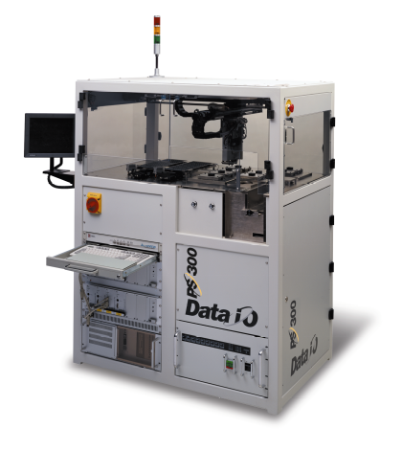


DATA I/O Corporation

10525 Willows Road NE
Redmond, WA 98052
Phone: 1.425.881.6444
Phone: 1.800.247.5700 (press 2)
FAX: 425.867.6972
FSE@dataio.com

Subject: Tray Feeder Installation on PP100 / PS-Series

Models Affected: PP100/PS200/300.

PURPOSE: Information on how to retrofit PP100/PS200/300 handlers with Tray Feeders.
TOOLS REQUIRED: Allen Key set SAE (inch) and metric, small wire cutter, small flat blade and crosshead screwdrivers and Tray Feeder Simulator Test Box

SOFTWARE REQUIRED: AH400 Ver.4.0 (or higher), part of “kit”

There are two types of Tray Feeders, an Input and an Output, and they are mechanically and electrically different.
After the modification as per this service bulletin, the “system” (i.e. PP100 or PS-Series) will be able to accommodate up to two Tray Feeders. The physical locations of these would be “Tray Feeder-1” and “Tray Feeder-2”.
Either Input or an Output Tray Feeder can be installed in one of these locations on the system.

If both Tray Feeders are installed or if Tray Feeder is installed at position-1 (towards the front of machine – see page-13) then Tube Feeder can not be used and it’s vibratory motors need to be removed from the system.

To use the Tray Feeder(s) the handler software AH400 must be at Version 4.0 or higher, along with it’s corresponding WinAH400.ini file entries.

Shutdown the system, turn off the main power and disconnect electric power cord coming into the system.
Turn off the air supply to the unit and disconnect the air hose coming into the system.
Remove all media, devices and adapters from the work envelope.
Remove the lower left side access door (panel) by opening the door and removing 2 screws from each of the 3 hinges. Do not remove the hinges from the frame of the system.
From both Tray platforms remove the FO (fiber optic) cables, which have blue ends, by loosening the small setscrew on the top, using a 0.050” hex wrench. Wind these FO cables into a roll and tie and secure them under the base plate.

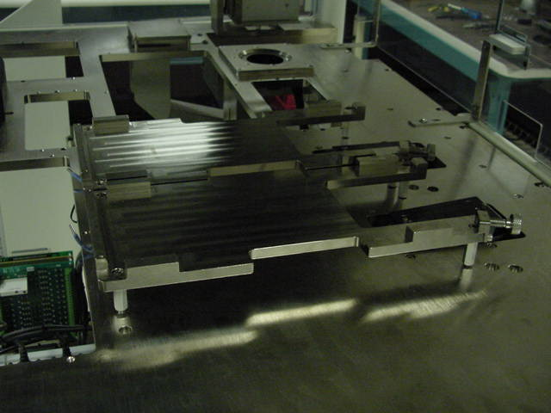

Remove both Tray platforms and then also remove the 8 stand-offs for these platforms.

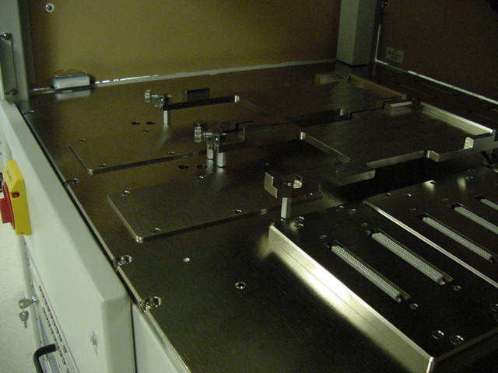

Tray Platform Stand-offs. Remove all 8 pieces.

From systems equipped with Tube Feeders, remove both vibratory motors, by first disconnecting their power cables. Remove 3 screws from each motor and remove the motor.

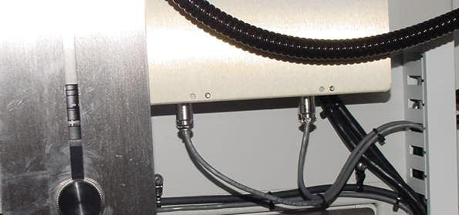

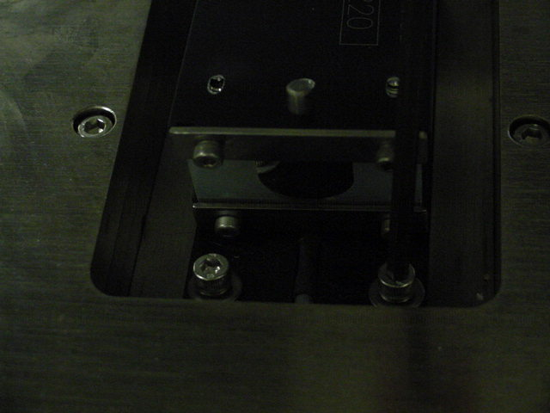

In configurations where Tray feeder is being installed in Position-2 only, then Tube Feeder vibratory motors need not be removed and can stay in place.

(b) Install the vertical Door Stop between cable guide and
frame of the system
and tighten screws
(a) Loosen screws from the vertical cable guide (channel) (not from Hinges)

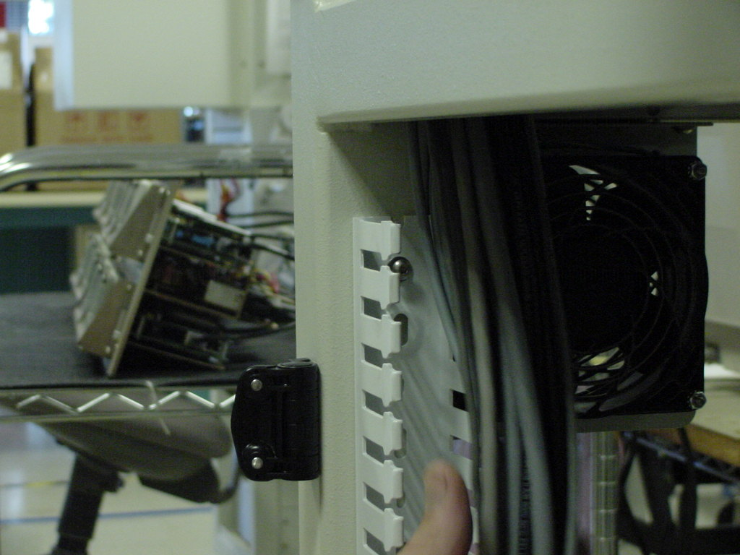

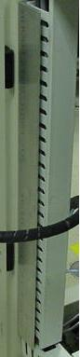
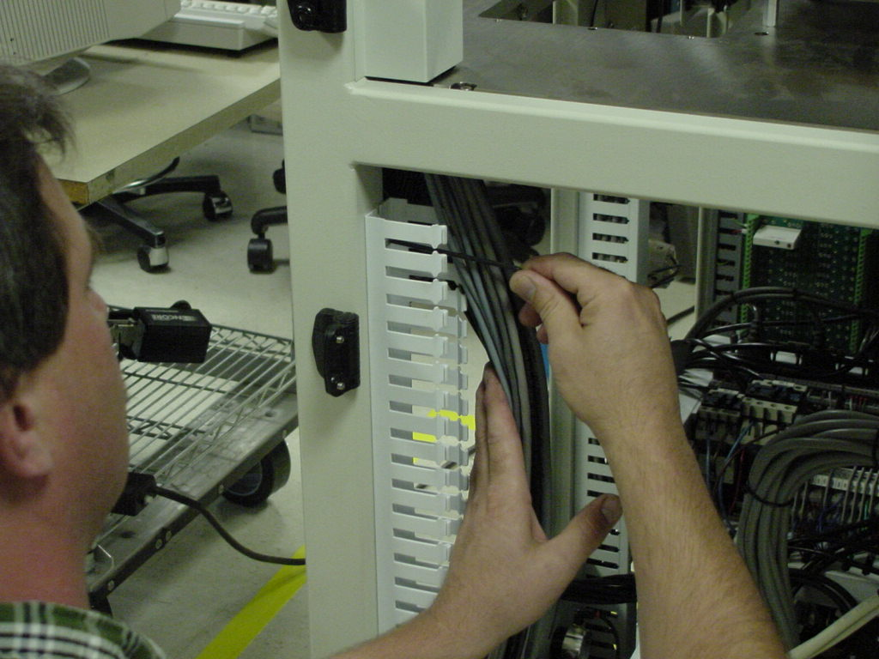
(c) Re-install all the cables in the cable guide and close it’s cover.

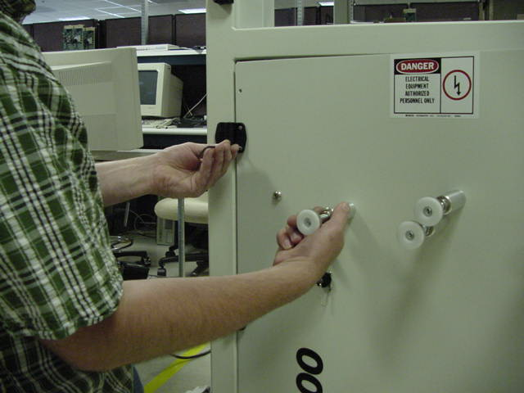
When door is installed, the Door Stop should as shown below.
Install air tube and wires in the vertical cable guide and close the cover of channel guide. Once done it should be as shown in picture.
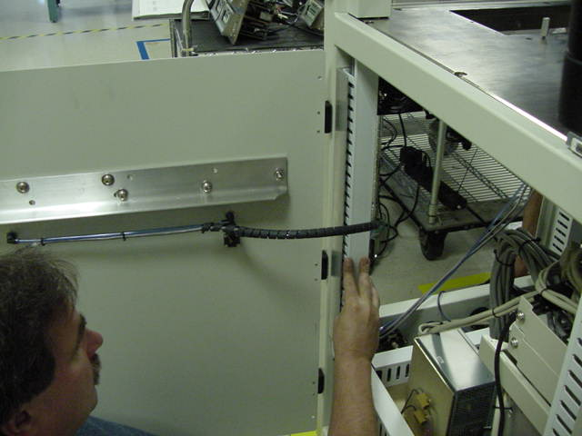
Tray Feeder-1 at Position-1
Tray Feeder-2 at Position-2
Tray feeder-1
Tray feeder-2

Route the cables into the second wire way.

From the vertical wire way (channel) take the air hose out.
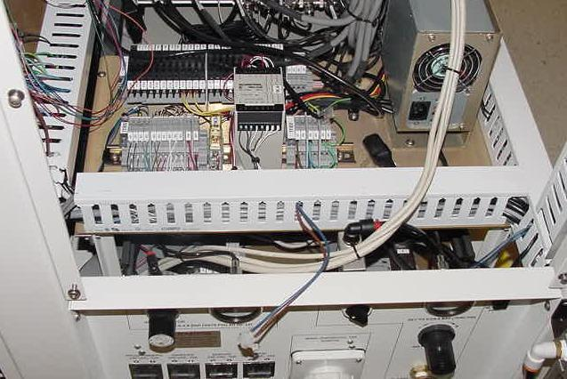
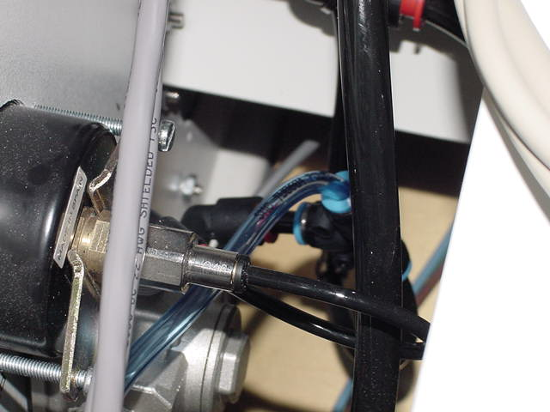
Disconnect the lower hose from the elbow and reattach it to new Tee. Install new Tee as shown – blue tube to Tray Feeder on top, old black tube on the bottom.
New Tee with air tubes
Blue Tube for air supply to Tray Feeders
Orignal Elbow with new tube
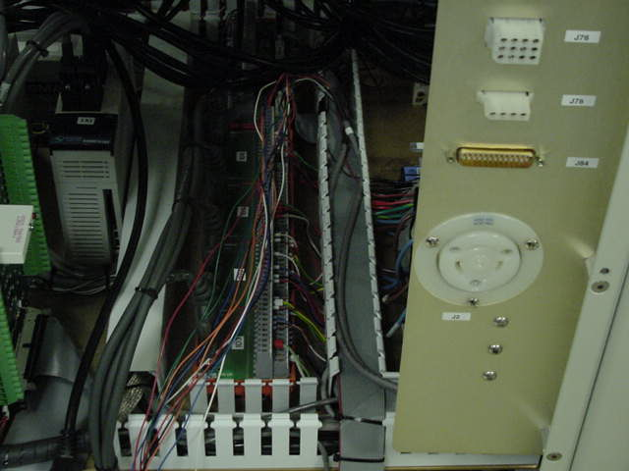
Feed the wires through horizontal wire way (channel)
Locate Terminal Block 1D3 and remove the black wires from terminals marked #8 and #19. Insulate both wires separately and place then in the cable guide.
Tray Feeder –1 Signals and Wire Connection Table

Signal Name Wire Color Terminal Block Terminal #
+24VDC Red 1TB1 4E

Common Black 1TB1 2E
Index Green 1D9 19
Ready White 1D3 19
Error-1 Blue 1D5 2
Error-2 Orange 1D5 16

Tray Feeder –2 Signals and Wire Connection Table

Signal Name Wire Color Terminal Block Terminal #
+24VDC Red 1TB1 5E

Common Black 1TB1 3E
Index Green 1D9 8
Ready White 1D3 8
Error-1 Blue 1D5 5
Error-2 Orange 1D5 19

Besides the above connections, install a jumper wire, provided in the kit, between 1E on 1TB1 and 1 on 1D9

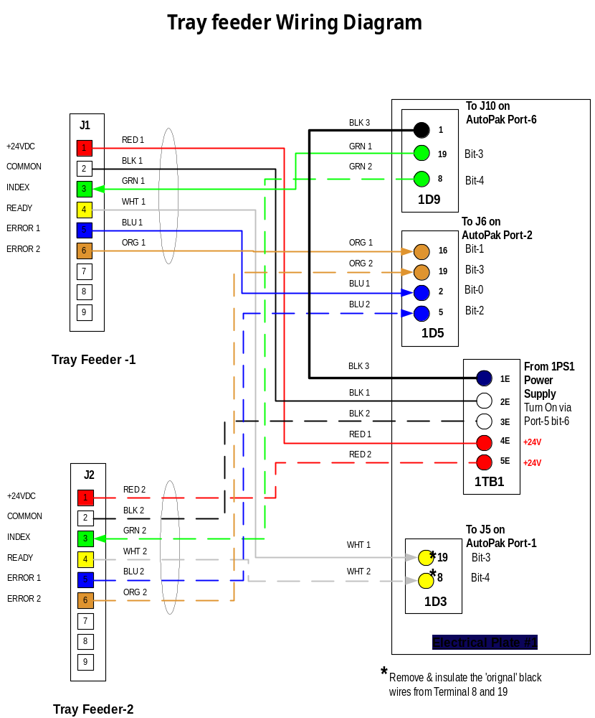
Install mount for Tray Feeders and tighten the four screws.
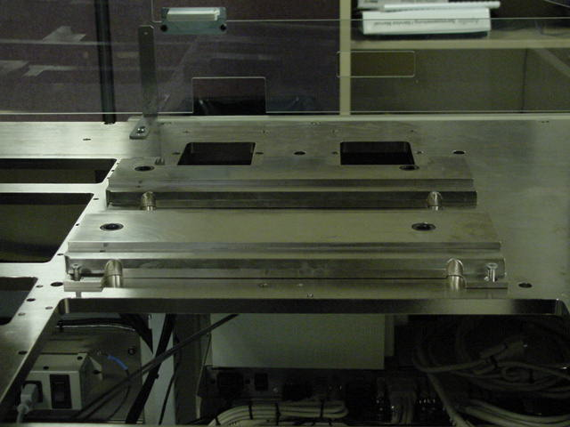
Note the mating guide on the base plate. The guide pin on Tray Feeder will go into this mating hole.
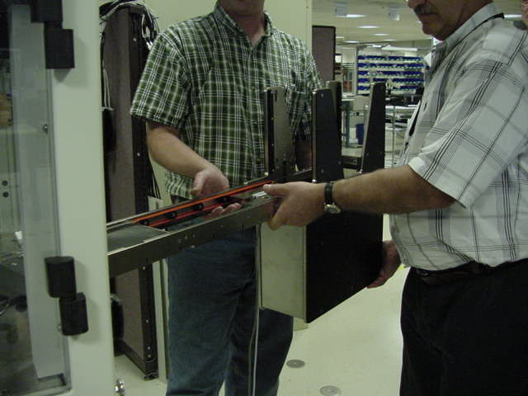
Lift and install one Tray Feeder as shown here.

Loader in Position-1 and
Unloader in Position-2

Ensure the upper door is closed and both covers are in open position. If only one Tray Feeder is installed, close the correspoonding door opening cover..

WARNING:
Tray Feeders are heavy!
They weighs ~ 60 pounds each (~ 27Kg) and should be handled by two people as shown.
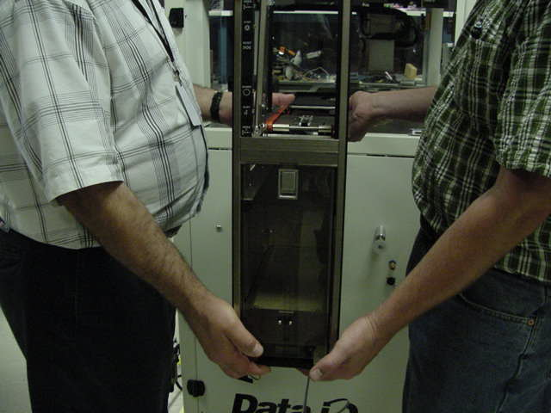
Remove the top left transparent door on the System (not shown here) and install the new door, with sliding covers, in it’s place.
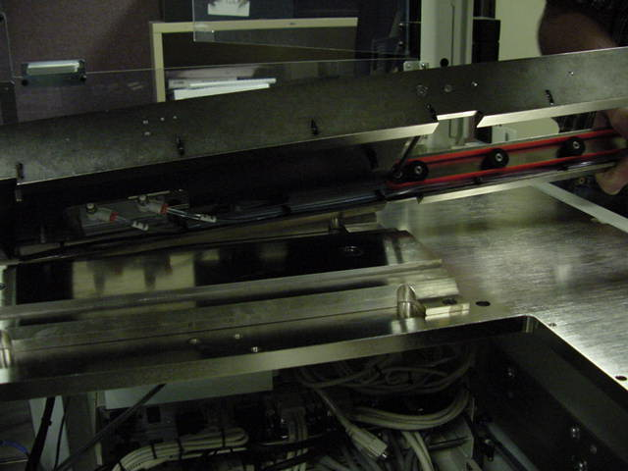
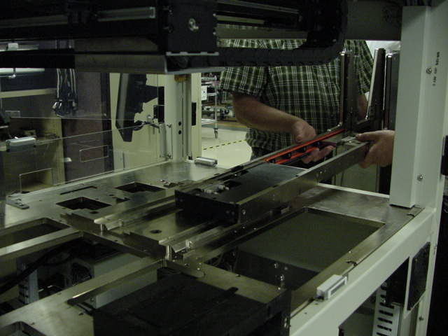
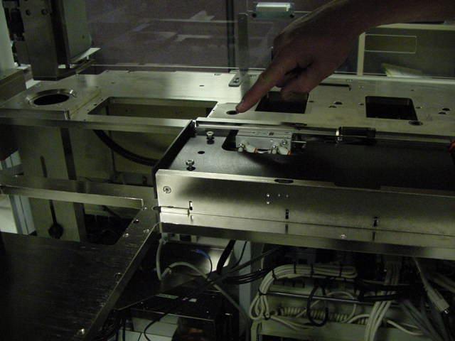
Insert the guide pin into the base plate hole.
Once the Tray Feeder is in place, tighten the two captive hex screws. Repeat the above steps for the seconf Tray Feeder.
WARNING
Tray Feeder should be supported from the back until both screws are tightened, otherwise injury can occur.
Locate supports on the door and open them up so that they touch the body of the Tray Feeder.

Apply hand torque and engage with the body of Tray Feeder

Secure support in place by jam nuts.

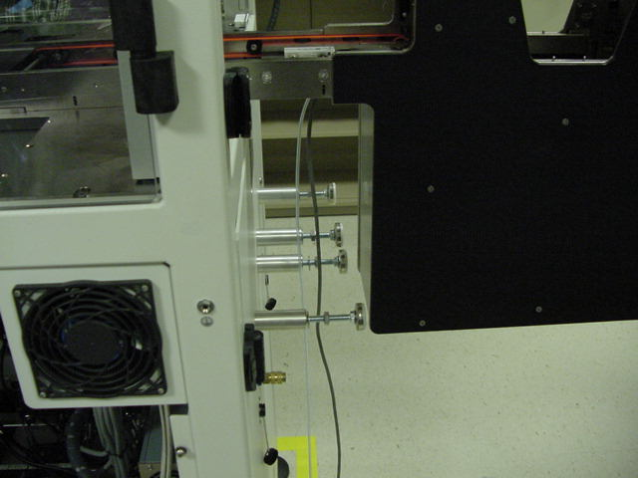
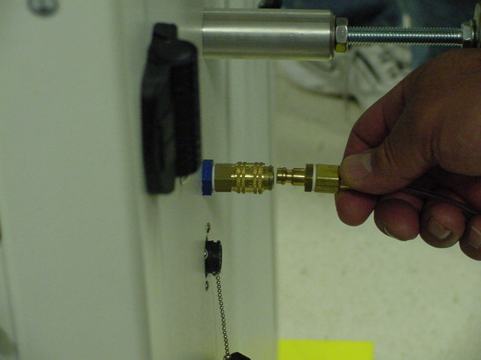
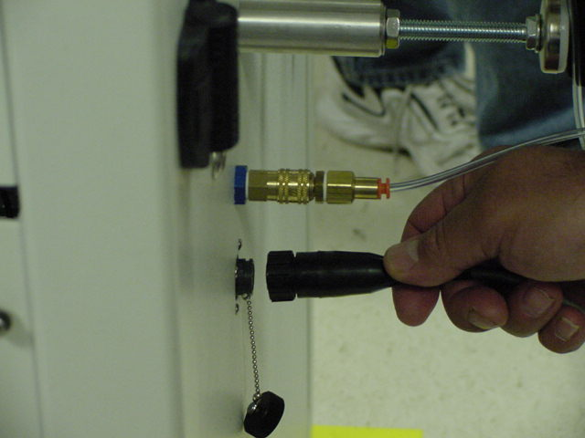
Install air connector by pushing it in

Insert and screw-on the Tray Feeder Simulator into this connector.

Power-on the unit and start USICheck sfotware …
(see next page)

Once connections / voltages are confirmed, disconnect the Simulator and connect the Tray Feeder.

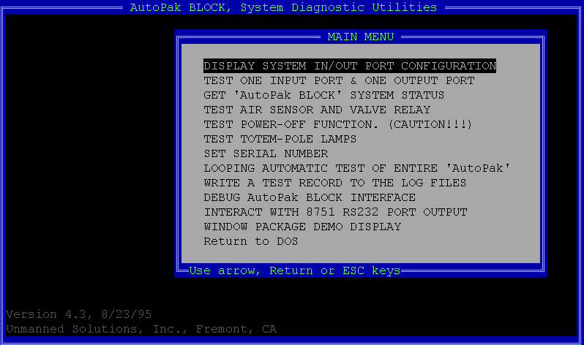
AutoPak USICHECK software utility

Launch C:\INSTALL\MEI and Autopak\USICHECK.exe. software from Handler computer
Use down arrow to select TEST ONE INPUT PORT & ONE OUTPUT PORT

On the “CHOOSE AN INPUT AND AN OUTPUT PORT TO TEST SCREEN” use up/down arrows to first select Port-1, Input, press Enter key, select Port-5, Output, press Enter and then go to “Accept Selection” and press Enter key.
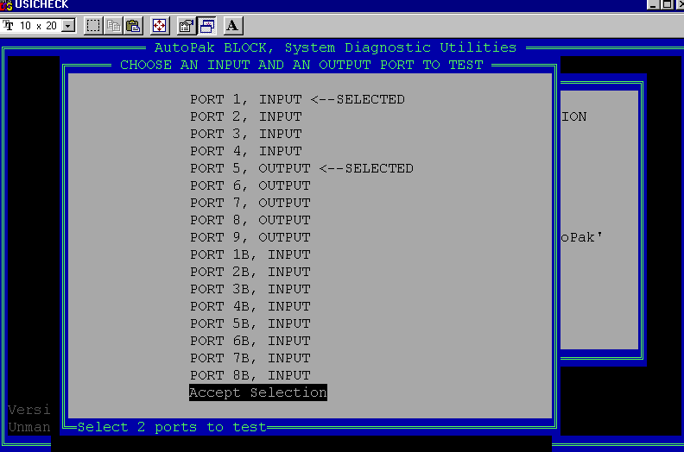
After the “Accept Selection”, another window “SELECT BIT TO TOGGLE ON/OFF” will open up, as below:-
In this window, the 9 AutoPak ports are labeled 0 through 8,

Choosen Port Displayed Port on SELECT BIT screen
PORT-1, INPUT Input Port-0
PORT-5, OUTPUT Output Port-4

Top portion shows Output Port bit-0 to bit-7, which can be toggled On/Off by selecting it and pressing Enter key, sending command/signal from the AutoPak.

Status, as sensed by the Input Port of the AutoPak is displayed on the bottom half, for bit-0 to bit-7 and they can be either ON or OFF.

On the front of AutoPak there are LEDs, grouped into ports, from Port-1 through Port-9, with 8 LEDs each for bit-0 to bit-7 respectively.

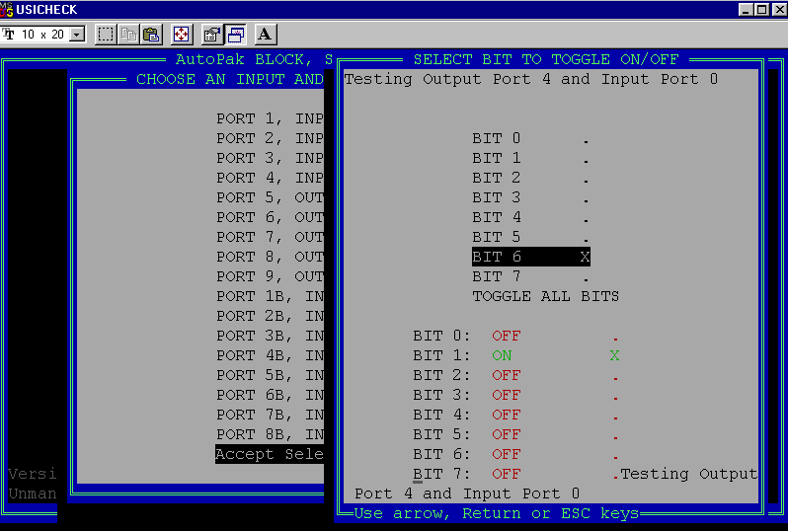
Tray Feeder Simulator Test Procedure

TF#1: Tray Feeder - towards the front of machine (nearest to LCD Display)
TF#2: Tray Feeder – towards the back of the machine.

To change Input or Output ports within USICHECK utility, press Esc key and From USICHECK’s CHOOSE screen, first select an Input port, press Enter and then an Output port, press Enter and finally press Enter on Accept Selection line.

To toggle bit On / Off first select the required bit and then press Enter key.

Selected Input Port | Selected Output Port | Action to be performed | Observation on USICHECK Screen | Observation on Tray Feeder Simulator
Port-1 | Port-5 | Toggle bit-6 On/Off on Port-5 |  | Power LED On/Off
Port-1 | Port-6  Output | Toggle bit-3 On/Off on Port-6 for TF#1 |  | INDEX LED On/OFF TF#1
Port-1 | Port-6 | Toggle bit-4 On/Off on Port-6 for TF#2 |  | INDEX LED On/OFF TF#2
Port-1 | Port-6 | READY switch – TF#1 on TF Simulator | Port-1 bit-3 On/Off | BIT 3 ON/X or OFF/.
Port-1 | Port-6 | READY switch – TF#2 on TF Simulator | Port-1 bit-4 On/Off | BIT 4 ON/X or OFF/.
Port-2 | Port-6 | ERROR-1 switch – TF#1 on TF Simulator | Port-2 bit-0 On/Off | BIT 0 ON/X or OFF/.
Port-2 | Port-6 | ERROR-2 switch – TF#1 on TF Simulator | Port-2 bit-1 On/Off | BIT 1 ON/X or OFF/.
Port-2 | Port-6 | ERROR-1 switch – TF#2 on TF Simulator | Port-2 bit-2 On/Off | BIT 2 ON/X or OFF/.
Port-2 | Port-6 | ERROR-2 switch – TF#2 on TF Simulator | Port-2 bit-3 On/Off | BIT 3 ON/X or OFF/.

If all above steps are positive, then testing of Tray Feeder connectors is complete and Tray Feeders can be connected safely. If not, power-down the machine, re-check the wiring and test again.

Port Bit Type Function
5 6 Output TF #1 & TF #2 +24 VDC on/ off
1 3 Input TF #1 Ready
1 4 Input TF #2 Ready
2 0 Input TF #1 Error 1
2 1 Input TF #1 Error 2
2 2 Input TF #2 Error 1
2 3 Input TF #2 Error 2
6 3 Output TF #1 Index on/ off
6 4 Output TF #2 Index on/ off

Fully installed Tray Feedes.
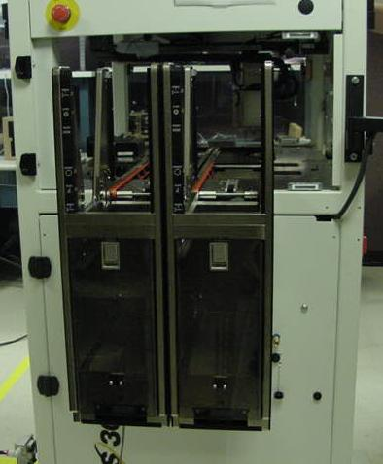
Install Power / Signal Connector
Tray Feeder – Position-2, towards the back of the unit.
Tray Feeder – Position-1, towards the front of the unit (near LCD Display)
Install AH400 from the CD in the Tray Feeder Installation Kit.

If the installation kit does not contain AH400 4.x, then add these lines in the C:\AH400_32\WinAH400.ini file:-

;-------- tray settings --------------------------------

;Automatic tray loader/unloader (Tray Feeder)by Laurier
; AUTOINLAURIER: Automatic Tray Loader (Tray Feeder)
; AUTOOUTLAURIER: Automatic Tray Unloader (Tray Feeder)
; STD: Manual tray holder
; Example: ModelTray1=STD
ModelTray1=AutoInLaurier
ModelTray2= AutoOutLaurier
;ModelTray1=STD
;ModelTray2=STD

For operation, adjustment and maintenance of Tray Feeders, refer to the Instruction Manuals of Tray Feeder that came in the Installation Kit.

Under Conveyor Speed Adjustment on page-20 of the TF Manual, there are details on adjusting the Conveyor Slow Down Speed. If μBGA devices are being used, them the forward Conveyor Slow Down Speed may need to be reduced.
The lower potentiometer within the elevator compartment controls this speed. Turning it CW (Clock Wise) Increases speed while CCW (Counter Clock Wise) reduces the speed.

